Lab Assignment 6

Fundamentals of Machine Learning

Name: M Jeyapathy

USN: 22BTRAD016

1. Implementing Numpy

# Import necessary libraries

import numpy as np

import matplotlib.pyplot as plt

from sklearn.datasets import make_classification

from sklearn.svm import SVC

# Create a small synthetic dataset

X, y = make_classification(n_samples=100, n_features=2, n_classes=2, n_clusters_per_class=1, n_redundant=0, random_state=42)

# Create an SVM classifier

svm_classifier = SVC(kernel='linear')

svm_classifier.fit(X, y)

# Visualize the decision boundary

plt.figure(figsize=(8, 6))

# Plot data points

plt.scatter(X[:, 0], X[:, 1], c=y, cmap=plt.cm.Paired, edgecolors='k', marker='o', s=100)

# Plot the decision boundary

ax = plt.gca()

xlim = ax.get_xlim()

ylim = ax.get_ylim()

# Create grid to evaluate model

xx, yy = np.meshgrid(np.linspace(xlim[0], xlim[1], 100), np.linspace(ylim[0], ylim[1], 100))

Z = svm_classifier.decision_function(np.c_[xx.ravel(), yy.ravel()])

# Plot decision boundary and margins

Z = Z.reshape(xx.shape)

plt.contour(xx, yy, Z, colors='k', levels=[-1, 0, 1], alpha=0.5, linestyles=['--', '-', '--'])

# Highlight the support vectors

plt.scatter(svm_classifier.support_vectors_[:, 0], svm_classifier.support_vectors_[:, 1], s=200, facecolors='none', edgecolors='k')

plt.title('SVM Decision Boundary')

plt.xlabel('Feature 1')

plt.ylabel('Feature 2')

plt.show()

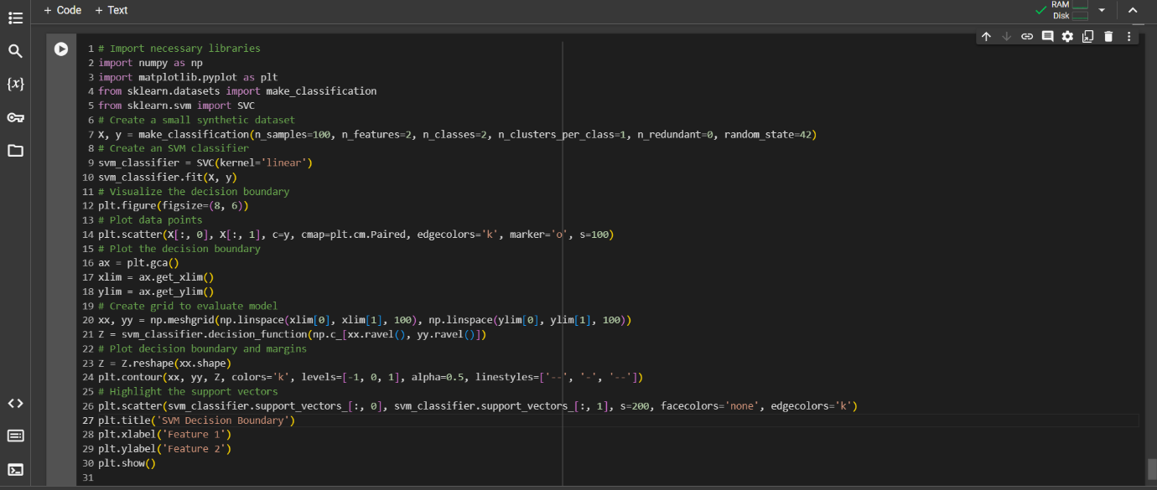

Output:

